1. API TO RETRIEVE A SPECIFIED CRYPTOCURRENCIES TRADE PAIR BEST AGGREGATED PRICE FROM DB:

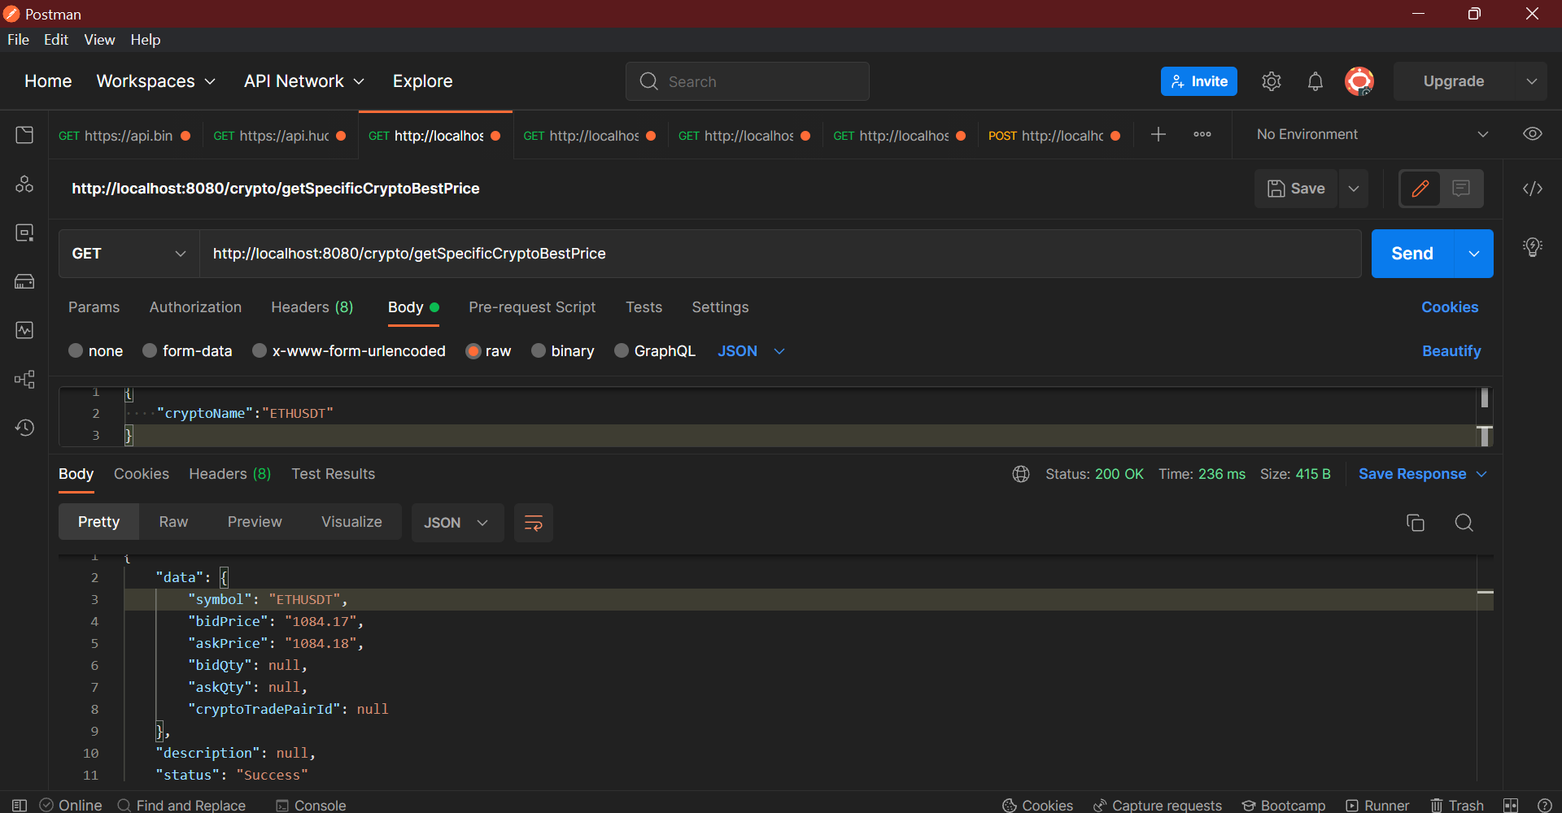

2**. API TO RETRIEVE ALL CRYPTOCURRENCIES TRADE PAIR BEST AGGREGATED PRICE FROM DB:**

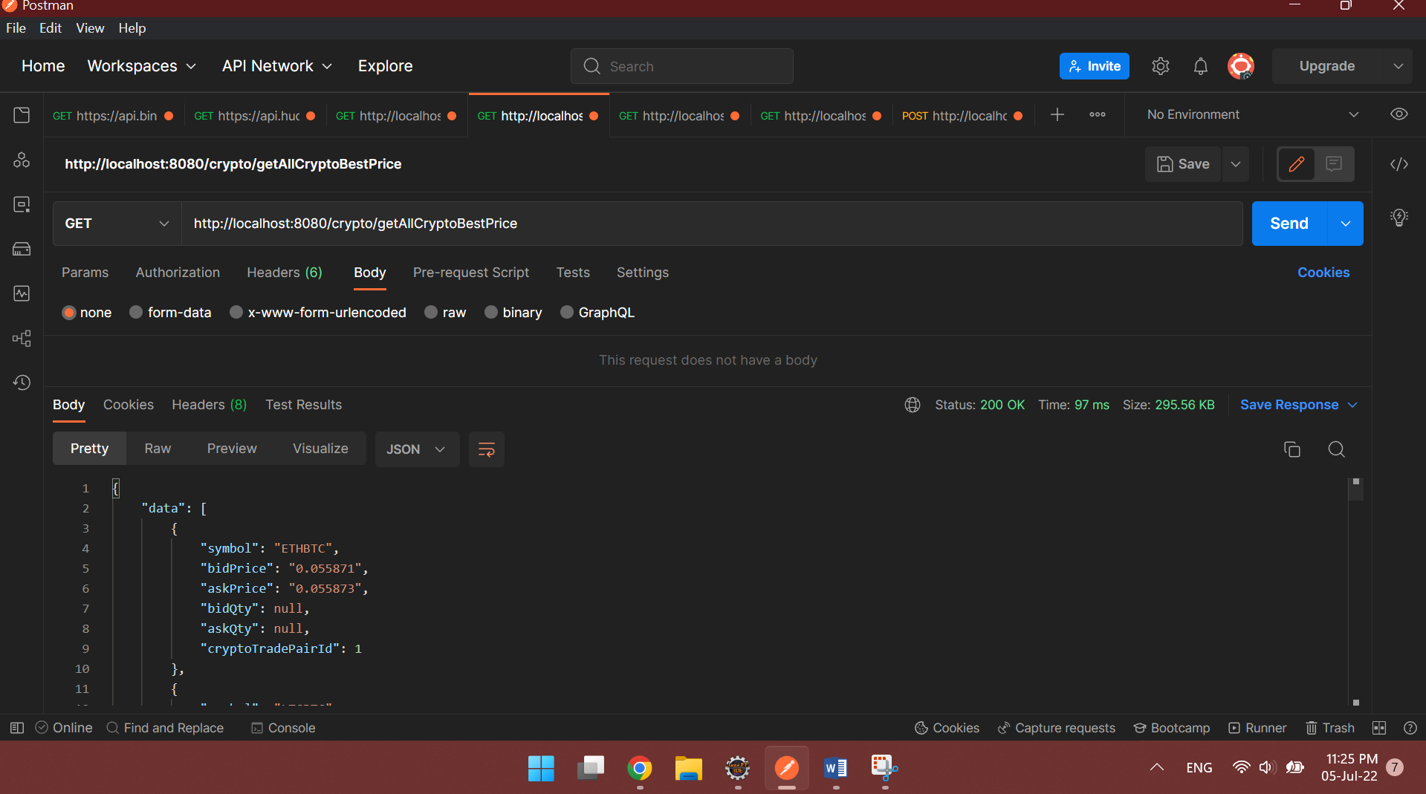

3. API WHICH ALLOW USERS TO TRADE BASED ON THE LATEST BEST AGGREGATED PRICE:

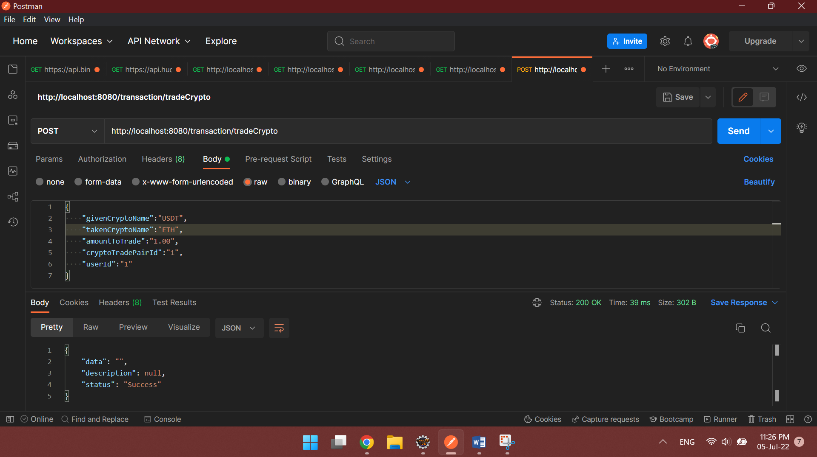

4. API TO RETRIEVE ALL THE USERS CRYPTOCURRENCIES WALLET BALANCE:

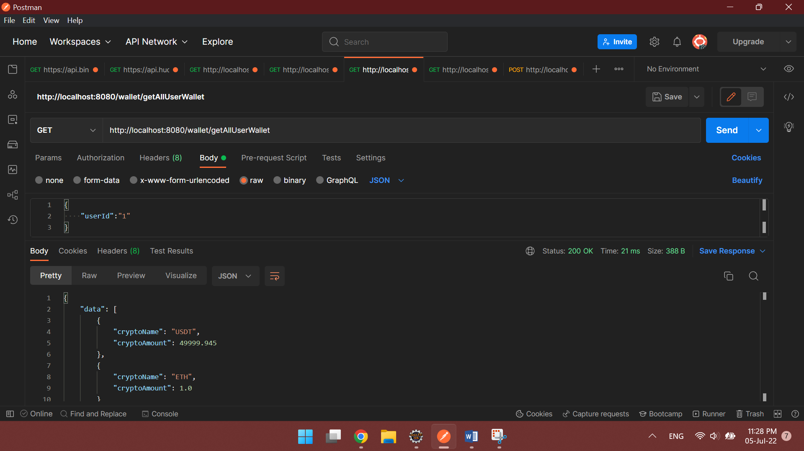

5. API TO RETRIEVE ALL THE USERS TRADING HISTORY:

